LAB 7

Solve below questions:

1. Print the first 10 natural numbers using for loop

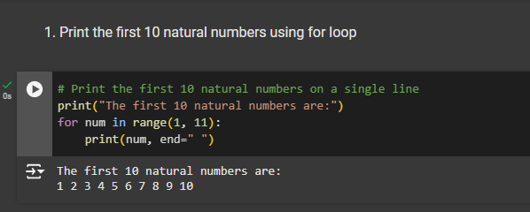

2. Python program to check if the given string is a palindrome

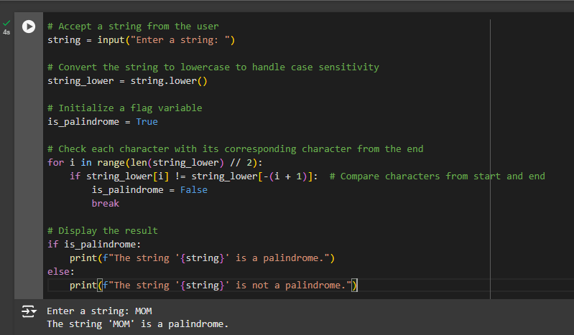

3. Python program to check if a given number is an Armstrong number

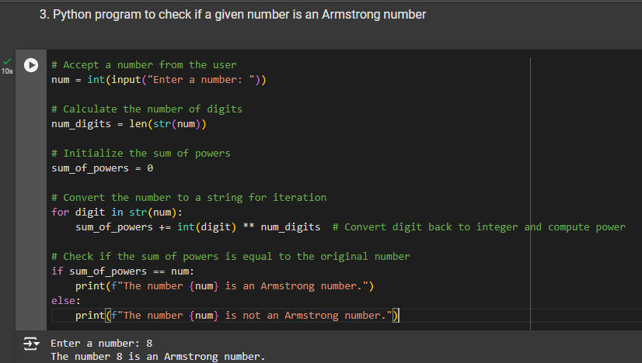

4. Python program to get the Fibonacci series between 0 to 50

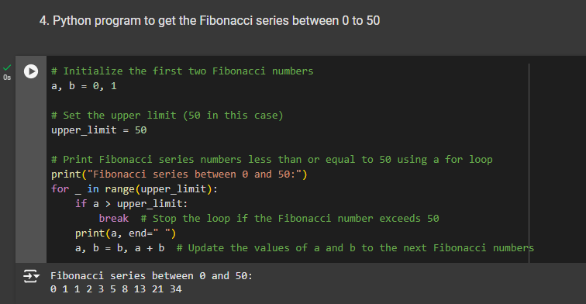

5. Python program to check the validity of password input by users

